#Generating text using Greedy Decoding

#Generating text using Beam Search

# Text generation using Repetition Penalty
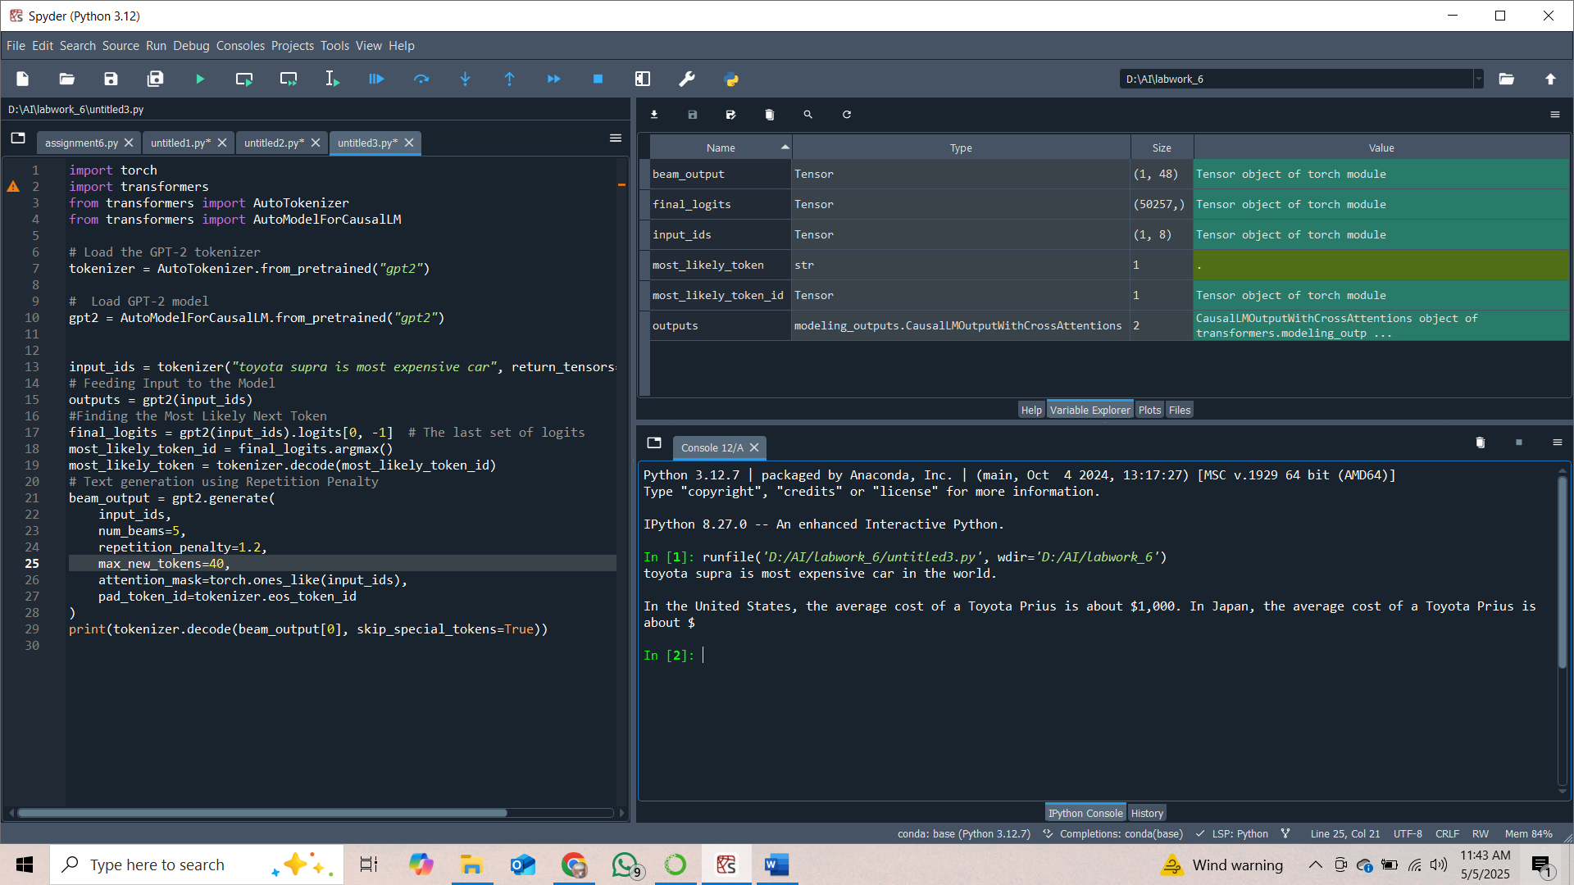
# Text generation using Temperature
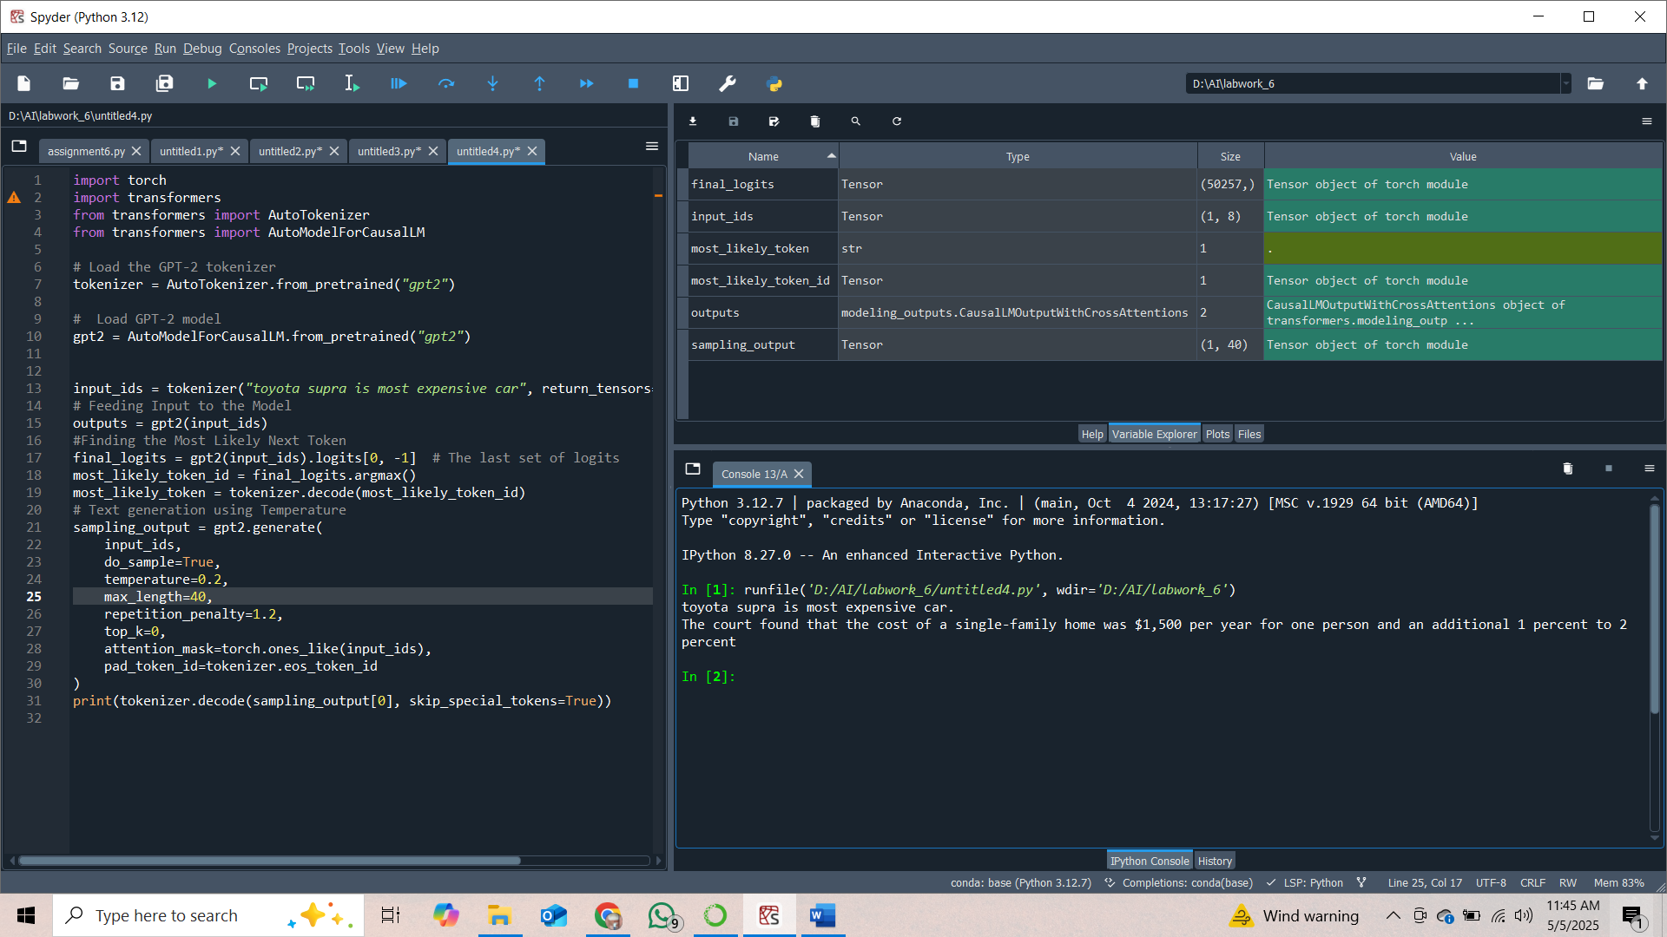

# Text generation Top-K Sampling
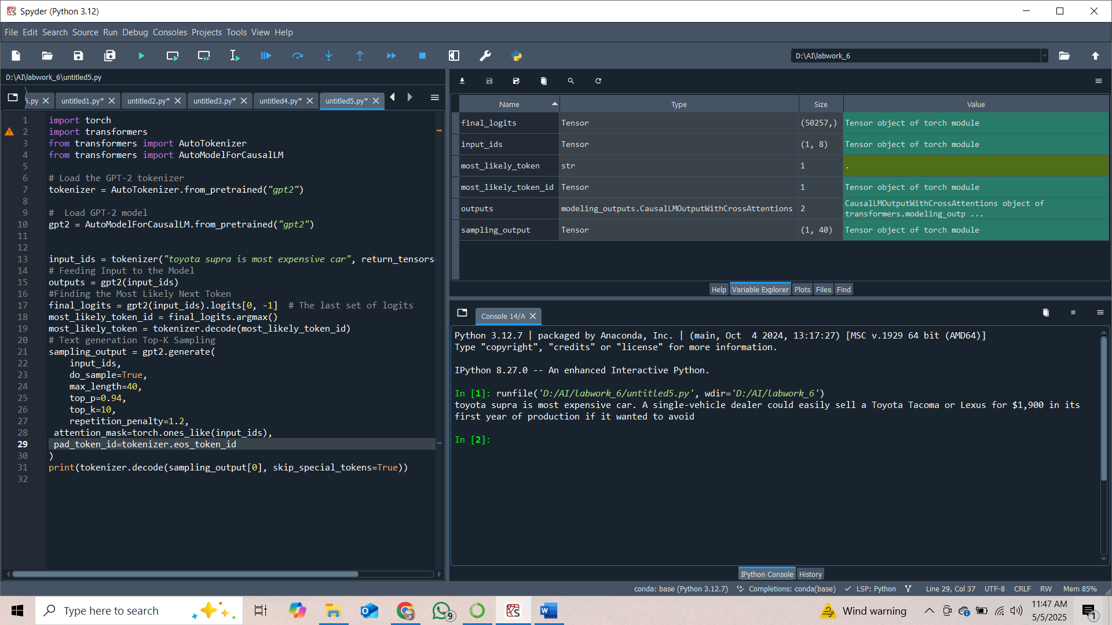
# Top-P (Nucleus) Sampling
